Steps to launch an instance in AWS:

Step 1: Select the EC2 option under Compute under Services

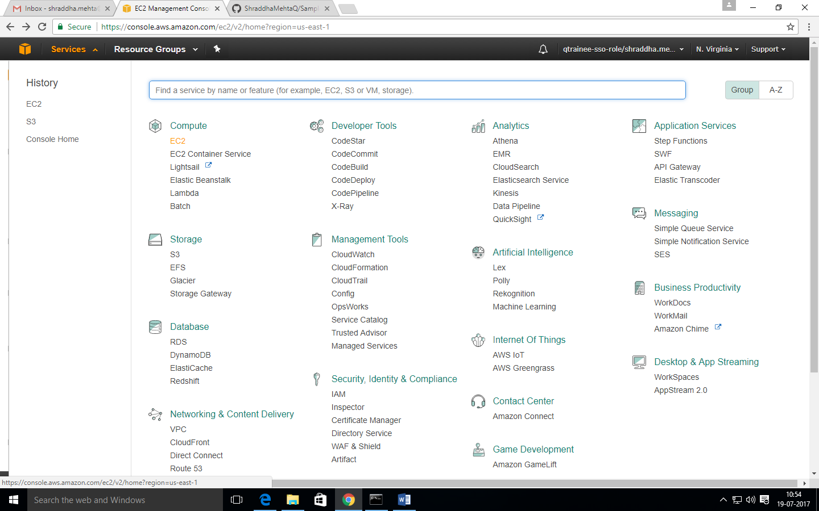

Step 2: Click on ‘Launch Instance’ button under Create Instance

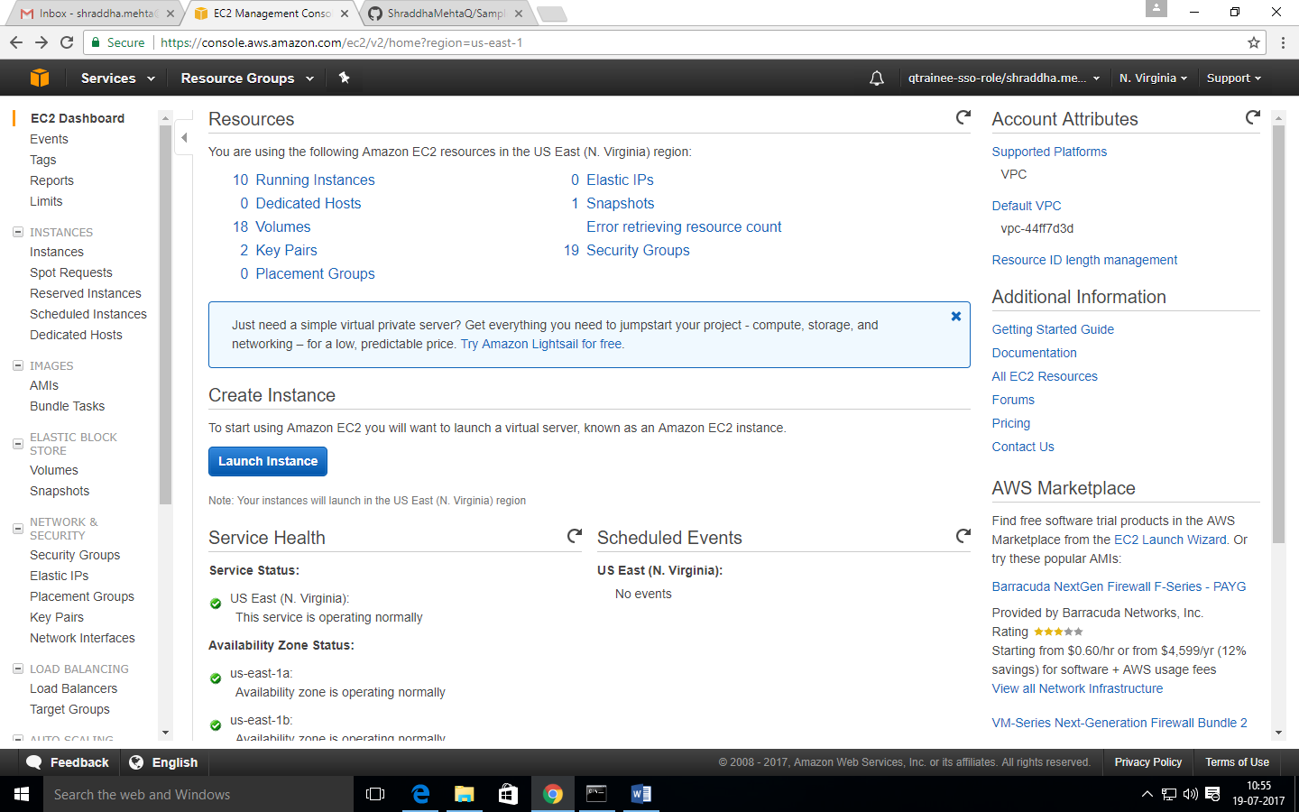

Step 3: Choose an Amazon Machine Image (AMI). In this case, **Amazon Linux AMI 2017.03.1 (HVM), SSD Volume Type** - ami-a4c7edb2. Press Select

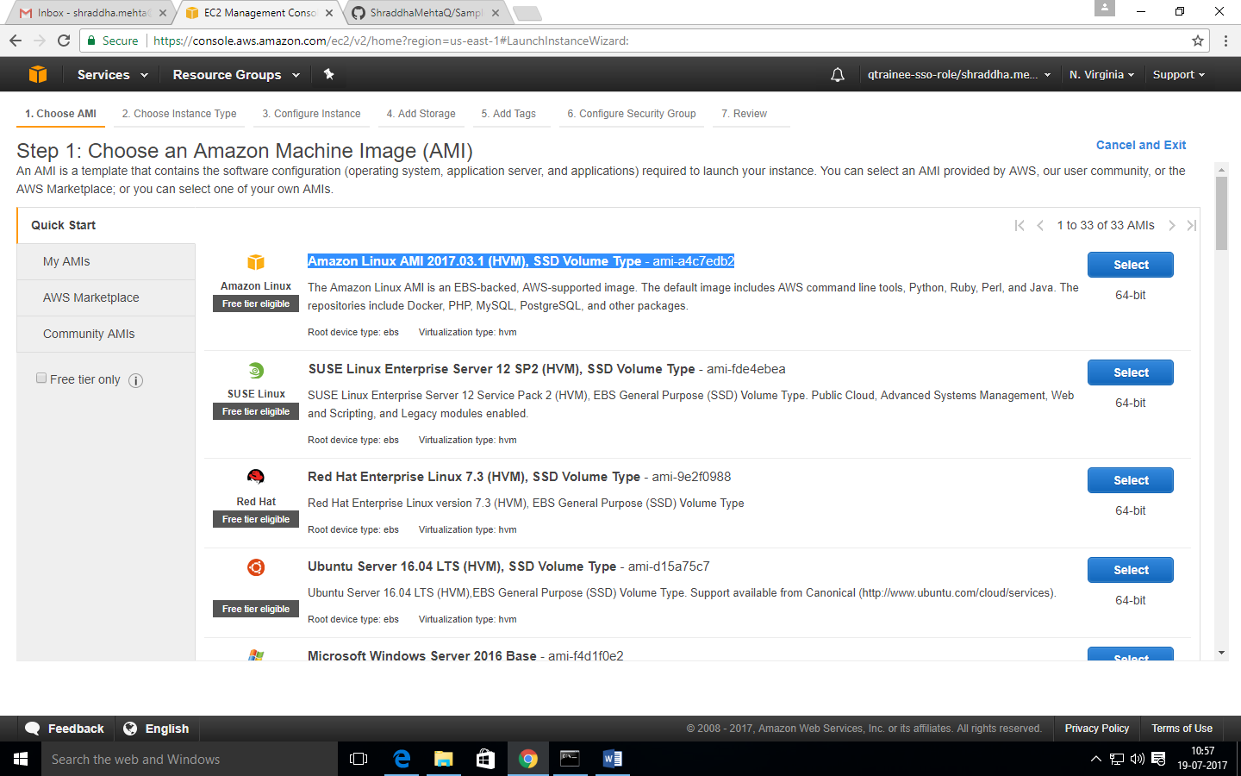

Step 4: Choose an instance type. In this case, we are choosing the one that is highlighted

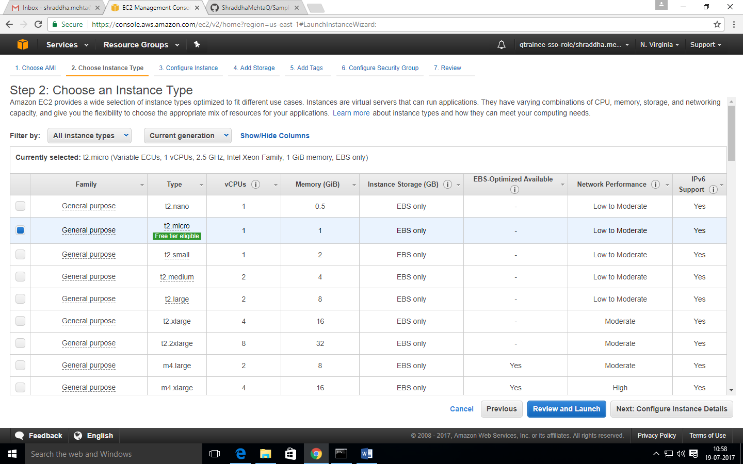

Step 5: Now configure the instance details

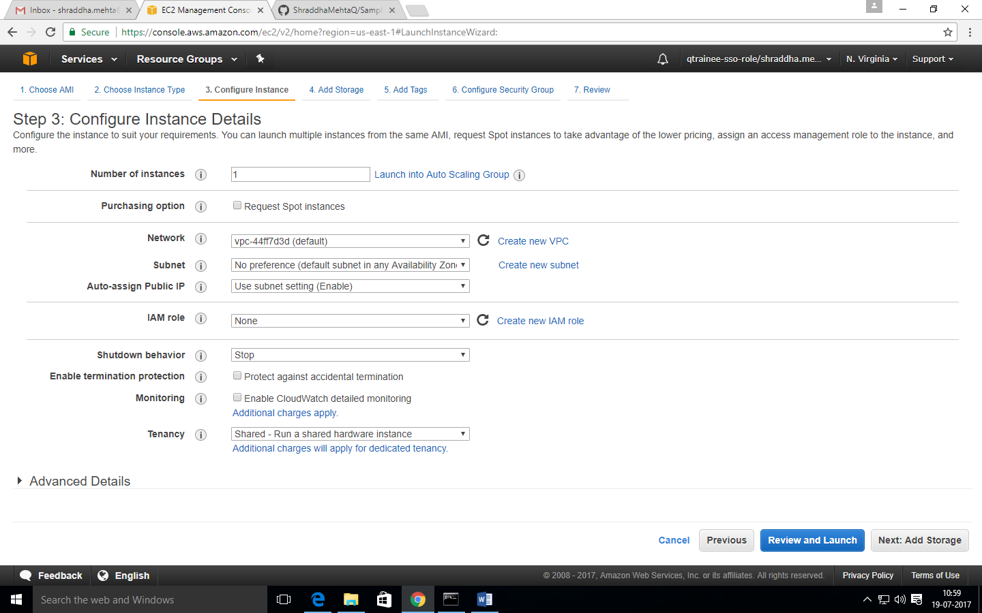

Step 6: Now have a look at the storage device stings and make the necessary changes

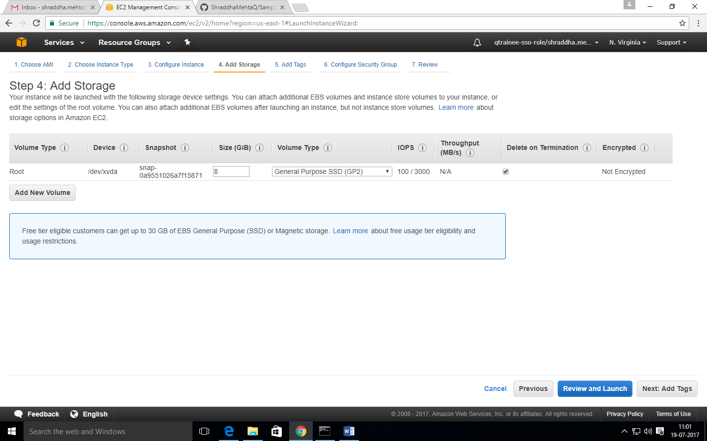

Step 7: Add relevant tags

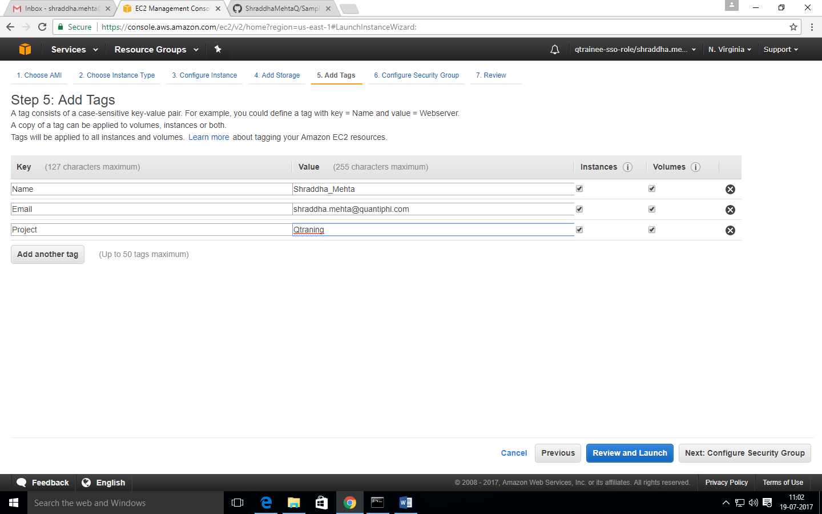

Step 8: Configure security group

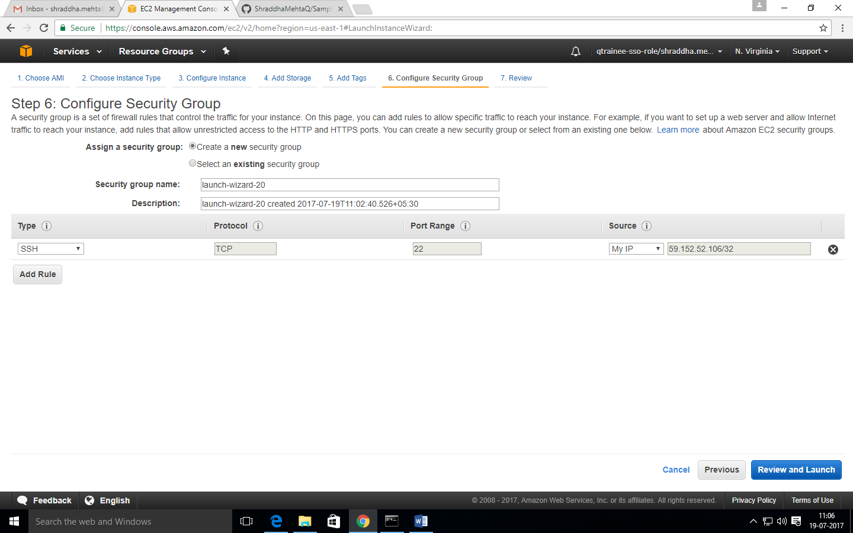

Step 9: Review and Launch

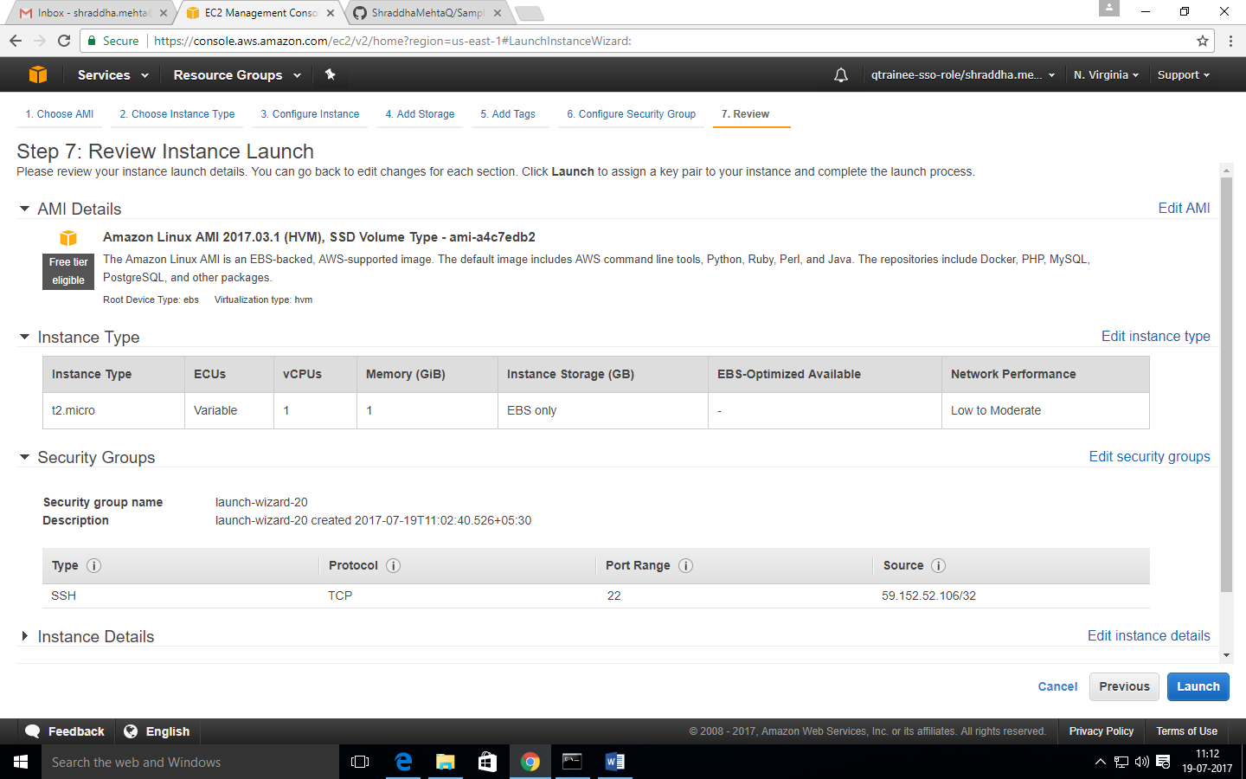

Step 10: Select the relevant option in the key pair and click on Launch Instances on the bottom down corner

